*Determines the purpose of analytics as a decision-making tool or a “people business”, uses Tableau to present stock price data*

**Assignment**

**1**

A1

ALY6050 Decision Support & Business Intelligence

Assignment 1 – Analytics & Influencing

**PREPERATION:**

By: John DiSessa

For: Professor Ellis

On: May 29th, 2022

Introduction

We were first tasked with determining if analytics is considered a “people business” and if the role of analytics is to influence decision making. We cited examples from Randy Bartlett’s textbook, course materials, and external sources to determine the ultimate role of analytics. We compared signals vs noise as well as the role of data interpretation that successful corporations utilize. In Part Two, we analyzed stock price data from Amazon, Google, Tesla, Nvidia, and Twitter to create a Tableau dashboard and make recommendations as to whether these companies should issue stock splits. We compared the data from the last 5 years with our Volume, Price, and Growth indicators in order to advise the presidents of each company.

Part One

**Signals & Noise**

Analytics is undoubtedly a “people business”. Even though humans can create algorithms to automatically make decisions, the best decisions are made with both analytical and human considerations. Focusing too heavily only on data or only on human intuition will lead to less-than-optimal results. For example, Microsoft created a Twitter chat-bot called TayTweets in 2016 that interacted with millennials on the platform. Their goal was to gather data, conduct research, and learn how millennials interact in order to better target products for them. This algorithm was able to read and process almost every tweet ever tweeted by a millennial. It was able to process an unfathomable amount of data. However, one of the main problems was that it was not able to fully understand sarcasm or properly tweet sarcastically. It tweeted our neo-Nazi propaganda that the Holocaust was not real, which resulted in the project being shut down, Microsoft facing public backlash, and many wasted resources.

On the flip-side, not using enough data can also lead to failure. Kodak filed for bankruptcy in 2012 because they failed to understand industry trends and changes in consumer attitudes. The switch in consumer preferences towards digital cameras went almost unnoticed by Kodak leadership. Ironically, Kodak developed the first ever digital camera in 1975 so Kodak’s failure was not due to technological changes. If Kodak had tracked and analyzed consumer data, they would have been able to notice a declining interest in film and an increasing desire for handheld digital cameras. They could have developed a whole line of digital cameras and even re-branded their digital camera line. These types of corporate decisions should only be made with the data to rationalize corporate strategy. Without the data, they trusted the intuition of their leadership who were unable to process and understand the severity of the changing consumer attitudes.

**Interpretation**

Another factor that proves analytics is a people business is that human interpretation of data is an essential component. Big Data, as its name suggests, is inherently a collection of data points that would normally be impossible to quantify only by humans. Big Data can be categorized by the four V’s: Volume, Velocity, Variety, and Veracity.

* Volume: potentially terabytes worth of information
* Velocity: the rate at which new data is added or existing data changes
* Variety: includes all types of data, structured or non-structured
* Veracity: data must be of adequate quality and be useful

With all different types of data changing and constantly being tracked, there will inherently be bad data, or more likely, misleading data points. Randy Bartlett stated corporations “will not know why they suddenly lost their customers one night or why their product is still on the shelves. They will have the data to explain it, yet they will struggle to put the pieces together in time because they will not be prepared… Corporations will continue to be awash in dirty data and filthy information. In a future emergency, they will race to clean the data, filter information from misinformation, and interpret the findings.” A company could have all the data in the world, but if they do not have intelligent analysts to properly interpret it, a purely analytics approach would lead to mixed results at best. People are at the core of analytics because they have the abilities to understand human resistance to change, macro-economic and consumer preferences, and the human condition. People know what people want. Humans are essential in identifying relevant and irrelevant data because they can see the bigger picture. Humans are capable of interpreting qualitative, quantitative, emotions, and feelings at once. As of right now, big data cannot do that.

**Decision Making**

Humans are estimated to make about 35,000 decisions a day. Many of which are seemingly insignificant, such as deciding which pair of socks to wear or how much toothpaste to use. However, some decisions are incredibly important and have ever-lasting implications, such as which jobs to apply for or how much to spend on a house. When you look at it from a corporate perspective, every decision becomes amplified. Not only does the success or failure of a business affect employee salaries, livelihoods, etc., but corporations compete with each other with almost every industry being a winner-take-all or winner-take-most industry. Since every industry is competitive, the margins for errors are small. Analytics provide the small edges that corporations can use to change their operations, strategy, or financial management. If companies invest in analytics, they expect analytics to provide them with data that confirms or denies existing opinions or even provide new insights into how the company should change. Like with any aspect of their business, they expect a return on investment. The data they get from their analytics departments can provide knowledge on consumers or competitors. That knowledge is inherently useful for influencing company decisions. The only scenario where knowledge is useful for knowledge itself is in a library. Since companies operate to make profits, they must use their data analysis to operate more optimally. At scale, it becomes a self-selecting part of any industry since companies that make data-driven decisions succeed and those that don’t fail. We don’t pay much attention to companies that consistently fail but try and learn from those successful companies. Because of the importance of big data in industries today, it becomes increasingly more likely that the most successful companies are the ones who utilize data the best. The data by itself is relatively useless since they are just numbers on a computer. But once you have analysts interpreting them and companies making data-driven decisions, the power of big data is unlocked.

Part Two

We created the following Tableau dashboard to analyze the stock prices of Amazon, Google, Tesla, Nvidia, and Twitter over the last 5 years. Our goal was to look at the data and determine if these companies should issue stocks splits. We look at price changes, 5-year growth rates, trading volume, and distance from previous all-time highs.

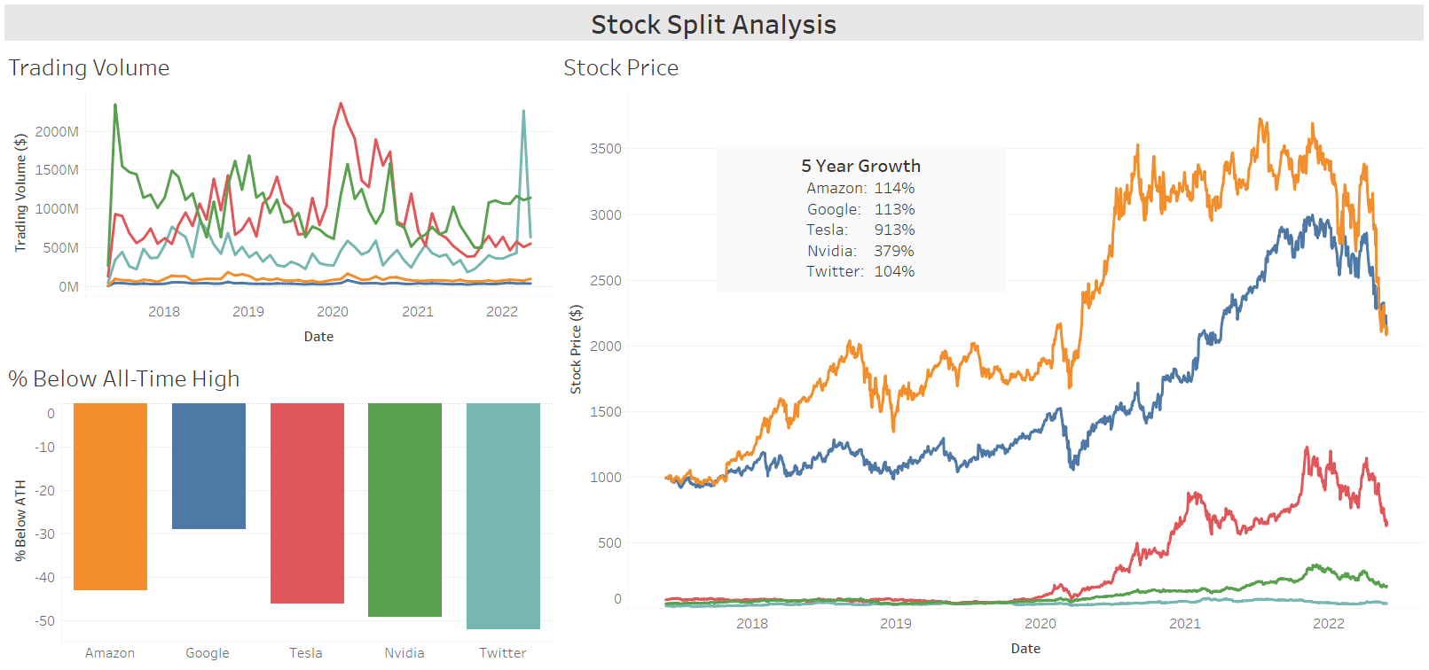Stock splits are financial maneuvers used by companies to alter their stock price without changing their valuations. Even though their market capitalizatinos stay the same following a stock split, they often have net positive results. We analyzed Trading Volume, Stock Price, and Growth as our 3 main factors in determining if these companies should issue stock splits this year. Stock splits are typically used to increase trading volume. Generally, high trading volumes indicate high demand for a stock which can put upward pressure on price. Stock splits generally occur when stock prices are high. Reducing a company’s stock price makes it more affordable to more investors. A diverse investor pool can increase a stock’s popularity while also reducing the likelihood of large investors (whales) manipulating the short-term price. Lastly, stock splits typically indicate a period of strong growth for a company. A company has grown so much in a short period of time that the stock price isn’t as affordable as they want it. In this instance, a high price but low liquidity shows that many of the holders are long-term holders. Long-term holders typically don’t sell as often as short-term holders so that decrease in available supply can have an upward pressure on price. However, this also means that the company is not attracting new investors. In our analysis, we looked for low trading volumes, high stock prices, and periods of strong growth as the 3 boxes we need checked before we can recommend a stock split.

**Stock Split Recommendations**

Both Amazon and Google are in almost identical situations. They have very low trading volumes considering how big their market capitalizations are, both have stock prices over $2,000, and have doubled in stock price over the last 5 years, despite being down 43% and 29% from their all-time highs, respectively. These two are textbook cases for issuing stock splits since they check all of the boxes. In fact, both have already announced 20:1 stock splits that will occur later this summer. Nvidia and Twitter, on the other hand, should absolutely not issue stock splits. They already have very high trading volumes, low stock prices of $170 and $37, and are both about 50% down from their previous all-time highs. They have had very good 5-year growth rates, however they still need to get back to their all-time high stock prices before even considering a stock split. Tesla is the most interesting case out of these 5 companies. They have moderately high trading volumes already, still have a fairly high stock price of $659, and an almost unprecedented 5-year growth rate of 913%. The trading volume suggests no stock split, the growth rate suggests a stock split, and the stock price does not give an indicator either way. If Tesla’s stock price can approach near their all-time high in the next 6 months, we would suggest a 5:1 stock split. Otherwise, a stock split would not be advisable.

Summary

This report showed our ability to conduct qualitative research as well as quantitative analysis. We cited course materials, textbooks, and external sources that led us to the determination that analytics is a “people business” and the ultimate goal of analytics is to influence decision making. We also processed lots of data and presented the stock price analysis in a beautiful and interactive Tableau dashboard that showed Amazon and Google should issue 20:1 stock splits this year. Our report covered many fundamentals of analytics while making clear and concise determinations.

Citations

Annierpalmer. “Amazon Announces 20-for-1 Stock Split, $10 Billion Buyback.” *CNBC*, CNBC, 10 Mar. 2022, https://www.cnbc.com/2022/03/09/amazon-announces-20-for-1-stock-split-10-billion-buyback.html.

Bartlett, Randy. “The Business Analytics Revolution.” *Practitioner's Guide to Business Analytics: Using Data Analysis Tools to Improve Your Organization's Decision Making and Strategy*, 2013.

Beek, Daan van. “Decision Making and Business Intelligence Tools.” *Decision Making and Business Intelligence Tools*, Passionned Group, 8 Oct. 2021, https://www.passionned.com/business-intelligence-tools-and-the-desicion-making-process/.

“Business Intelligence: What It Is, How It Works, Its Importance, Examples, & Tools.” *Tableau*, https://www.tableau.com/learn/articles/business-intelligence.

*Cboe Global Markets*, https://www.cboe.com/insights/posts/stock-splits-lead-to-split-results-in-trading/.

Hayes, Adam. “Stock Split.” *Investopedia*, Investopedia, 4 Mar. 2022, https://www.investopedia.com/terms/s/stocksplit.asp.

Hoomans, Dr. Joel. “35,000 Decisions: The Great Choices of Strategic Leaders.” *Robert's*, https://go.roberts.edu/leadingedge/the-great-choices-of-strategic-leaders#:~:text=Various%20internet%20sources%20estimate%20that,%26%20Labuzetta%2C%202013).

“How Does a Stock Split Benefit Shareholders.” *How Does a Stock Split Benefit Shareholders | Motilal Oswal*, https://www.motilaloswal.com/blog-details/how-does-a-stock-split-benefit-shareholders/20178.

Kurt, Daniel. “Stock Splits: A Closer Look at Its Effects.” *Investopedia*, Investopedia, 30 Mar. 2022, https://www.investopedia.com/articles/investing/020314/stock-splits-closer-look-its-effects.asp.

“What Is Big Data: Definition.” *Informatica*, https://www.informatica.com/services-and-training/glossary-of-terms/big-data-definition.html.